**WEB ENGINEERING (SE 319)**

**LAB 4**

**Name:** Syed Measum Hassan

**SECTION:** SE ( B)

**Roll Number:** 20B-058-SE

**Seat Number:** ST-20097

**LAB TASK1:**

using System;

using System.Collections.Generic;

using System.Linq;

using System.Text;

using System.Threading.Tasks;

namespace measumlab4

{

class Program

{

static void Main(string[] args)

{

Console.WriteLine("Task 1");

Console.Write("Enter Radius: ");

int r = Convert.ToInt32(Console.ReadLine());

double pi = 3.14;

double area = pi * r * r;

Console.WriteLine("Area of circle is: " + area);

Console.Write("Enter a: ");

int a = Convert.ToInt32(Console.ReadLine());

Console.Write("Enter b: ");

int b = Convert.ToInt32(Console.ReadLine());

Console.Write("Enter c: ");

int c = Convert.ToInt32(Console.ReadLine());

double area_of_triangle = (a + b + c) / 2;

Console.WriteLine("Area_of_triangle is: " + area_of_triangle);

}

}

}

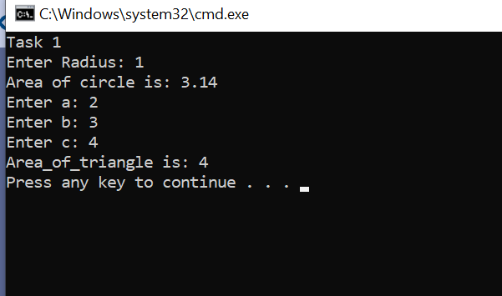

**LAB TASK2:**

using System;

using System.Collections.Generic;

using System.Linq;

using System.Text;

using System.Threading.Tasks;

namespace measumlab4

{

class Program

{

static void Main(string[] args)

{

Console.WriteLine("Task 2");

Console.Write("Enter num1 : ");

int num1 = Convert.ToInt32(Console.ReadLine());

Console.Write("Enter num2: ");

int num2 = Convert.ToInt32(Console.ReadLine());

Console.WriteLine("{0} + {1} = {2}", num1, num2, num1 + num2);

Console.WriteLine("{0} - {1} = {2}", num1, num2, num1 - num2);

Console.WriteLine("{0} x {1} = {2}", num1, num2, num1 * num2);

Console.WriteLine("{0} / {1} = {2}", num1, num2, num1 / num2);

Console.WriteLine("{0} mod {1} = {2}", num1, num2, num1 % num2);

}

}

}

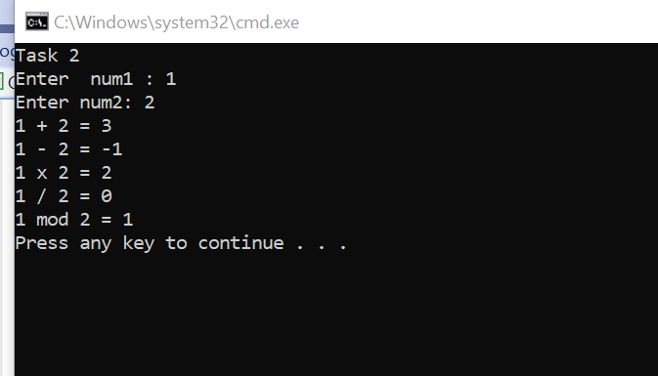

**LAB TASK3:**

using System;

using System.Collections.Generic;

using System.Linq;

using System.Text;

using System.Threading.Tasks;

namespace measumlab4

{

class Program

{

static void Main(string[] args)

{

Console.WriteLine("Task 3");

int i = 0;

Console.Write("Enter a: ");

int a = Convert.ToInt32(Console.ReadLine());

Console.Write("Enter b: ");

int b = Convert.ToInt32(Console.ReadLine());

Console.WriteLine("Even Numbers :");

for (i = a; i <= b; i++)

{

if (i % 2 == 0)

{

Console.Write(i + " ");

}

}

Console.WriteLine("\nOdd Numbers :");

for (i = a; i <= b; i++)

{

if (i % 2 != 0)

{

Console.Write(i + " ");

}

}

Console.WriteLine();

}

}

}

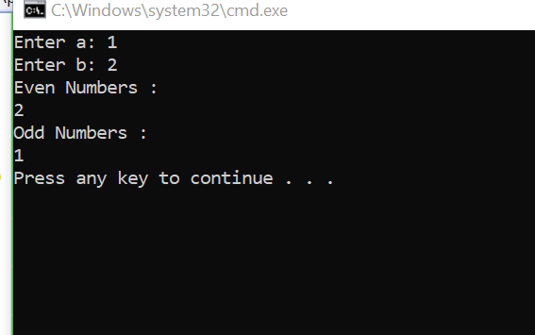

**LAB TASK4 :**

using System;

using System.Collections.Generic;

using System.Linq;

using System.Text;

using System.Threading.Tasks;

namespace measumlab4

{

class Program

{

static void Main(string[] args)

{

Console.WriteLine("Task 4");

Console.Write("Input A String : ");

string str1 = "";

string str = Console.ReadLine();

int i, l;

l = str.Length - 1;

for (i = l; i >= 0; i--)

{

str1 = str1 + str[i];

}

Console.WriteLine("The string in Reverse Order Is : {0}", str1);

Console.Write("\n");

Console.ReadKey();

}

}

}

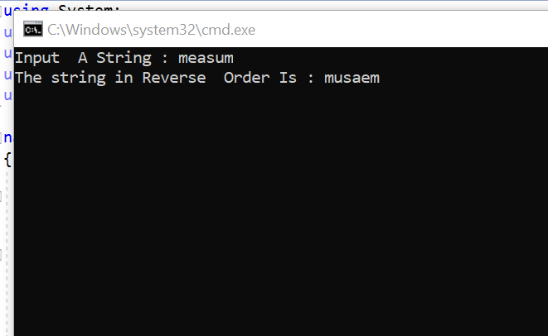

**LAB TASK5 :**

using System;

using System.Collections.Generic;

using System.Linq;

using System.Text;

using System.Threading.Tasks;

namespace measumlab4

{

class Program

{

static void Main(string[] args)

{

Console.WriteLine("Task 5");

Console.WriteLine("Enter item: ");

int search = Convert.ToInt32(Console.ReadLine());

int[] arr = { 4, 2, 1, 3 };

for (int i = 0; i < arr.Length; i++)

{

if (arr[i] == search)

{

Console.WriteLine("Found");

break;

}

else

{

Console.WriteLine("NotFound");

}

}

}

}

}

**LAB TASK 6:**

using System;

namespace measumlab4

{

class Program

{

static void Main(string[] args)

{

Console.WriteLine("Task 6");

int i, j, k;

for (i = 1; i <= 5; i++)

{

for (j = 1; j <= 5; j++)

{

if (j >= i)

{

k = j - i + 1;

Console.Write(k);

}

else

{

k = i - j + 1;

Console.Write(k);

}

}

Console.WriteLine();

}

Console.ReadLine();

}

}

}

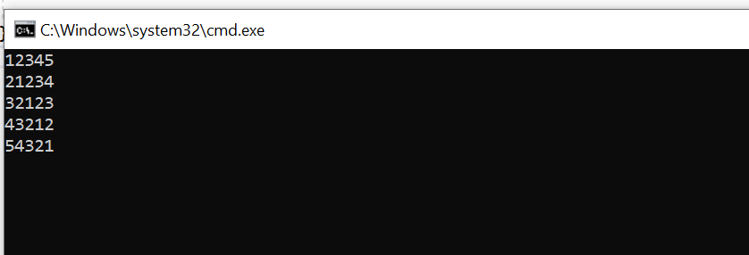

**LAB TASK 8:**

using System;

using System.Collections.Generic;

using System.Linq;

using System.Text;

using System.Threading.Tasks;

namespace

{

    class Program

    {Circle circle= new Circle();

 circle.AreaCalculation();

Console.WriteLine("------------------------------");

Triangle triangle = new Triangle();

triangle.AreaCalculation();

    }

class Circle

    {

        public void AreaCalculation()

        {

            Console.Write("> Enter the Radius of the Circle: ");

            double Radius = Convert.ToDouble(Console.ReadLine());

            double Area = Math.PI * Radius * Radius;

            Console.WriteLine("Area of circle: " + Area);

        }

    }

   class Triangle

    {

        public void AreaCalculation()

        {

            // taking input from the users

            Console.Write("> Enter the length of side 1: ");

            double side1 = Convert.ToDouble(Console.ReadLine());

            Console.Write("> Enter the length of side 2: ");

            double side2 = Convert.ToDouble(Console.ReadLine());

            Console.Write("> Enter the length of side 3: ");

            double side3 = Convert.ToDouble(Console.ReadLine());

           // Area calculations

            double semiperimeter = (side1 + side2 + side3) / 2;

            double Area = Math.Sqrt(semiperimeter * (semiperimeter - side1) * (semiperimeter - side2) * (semiperimeter - side3));

            Console.WriteLine("Area of a Triangle = " + Area);

        }

    }

}

**LAB TASK 7:**

using System;

using System.Collections.Generic;

using System.Linq;

using System.Text;

using System.Threading.Tasks;

namespace task7

{

    class Program

    {

        static void Main(string[] args)

        {

            int[,] arr = new int[4, 4];

            int sum = 0;

            for (int i = 0; i < 4; i++)

            {

                for (int j = 0; j < 4; j++)

                {

                    arr[i, j] = i + j;

                }

            }

            for (int i = 0; i < 4; i++)

            {

                for (int j = 0; j < 4; j++)

                {

                    Console.Write(arr[i, j] + " ");

                }

                Console.WriteLine();

            }

            for (int i = 0; i < 4; i++)

            {

                for (int j = 0; j < 4; j++)

                {

                    if (i == j)

                    {

                        sum = sum + arr[i, j];

                    }

                }

            }

            Console.WriteLine("Sum of diagonals is " + sum);

            Console.ReadLine();

        }

    }

}